Bahria University,

Karachi Campus



LAB EXPERIMENT NO.

**3**

LIST OF TASKS

|  |  |
| --- | --- |
| TASK NO | OBJECTIVE |
| **1** | Create login and registration form using simple MVC net core. |
| 2 | Create feedback form using simple MVC net core. |

Submitted On:

7 March 2024

____________

(Date: DD/MM/YY)

**Task 1**

Create login and registration form using simple MVC net core.

**Login View**

@model cclab3.Models.LoginViewModel.RegisterViewModel

@{

ViewData["Title"] = "Sign in";

}

<**form** method="post" **asp-action**="Login">

<section class="vh-80">

<div class="container1">

<div class="row d-flex align-items-center justify-content-center h-100">

<div class="col-md-4 col-lg-6 col-xl-5">

<img src="https://img.freepik.com/free-vector/secure-login-concept-illustration_114360-4582.jpg"

class="img-fluid" alt="Phone image">

</div>

<div class="col-md-6 col-lg-4 col-xl-4 offset-xl-1">

<h1>Sign in</h1>

<!-- Username input -->

<div class="form-floating mb-3">

<**input** **asp-for**="Username" id="floatingInput" class="form-control" placeholder="user" required />

<**label** class="form-label" **asp-for**="Username">Username</**label**>

</div>

<!-- Password input -->

<div class="form-floating mb-3">

<**input** **asp-for**="Password" id="floatingPassword" **type**="password" class="form-control" placeholder="12345678" required />

<**label** class="form-label" **asp-for**="Password">Password</**label**>

</div>

<!-- Submit button -->

<button type="submit" class="btn btn-primary btn-lg btn-block">Sign in</button>

<button type="button" class="btn btn-primary btn-lg btn-block reg" onclick="redirectToRegister()">Register</button>

</div>

</div>

</div>

</section>

</**form**>

@if (!string.IsNullOrEmpty(ViewBag.ErrorMessage))

{

<p style="color: red; font-size: 20px;">@ViewBag.ErrorMessage</p>

}

<style>

.divider:after,

.divider:before {

content: "";

flex: 1;

height: 1px;

background: #eee;

}

.vh-80 {

padding-top: 2rem;

}

.container1 {

background-color: white;

border-radius: 15px;

display: flex;

flex-direction: column;

}

.form-floating > .form-control {

border-radius: 15px;

}

button.btn.btn-primary.btn-lg.btn-block.reg {

color: #fff;

background-color: #1b2e35;

border-color: #1b2e35;

}

button.btn.btn-primary.btn-lg.btn-block {

margin-bottom: 0.7rem;

}

.btn-group-lg > .btn, .btn-lg {

padding: 0.5rem 1rem;

font-size: 1.25rem;

border-radius: 15px;

width: -webkit-fill-available;

font-weight: 200;

line-height: 1.7;

}

.h1, h1 {

padding-bottom: 1rem;

font-weight: 700;

}

</style>

@if (ViewData["Error"] != null)

{

<div class="alert alert-danger">@ViewData["Error"]</div>

}

<script>

function redirectToRegister() {

window.location.href = '/Home/Register';

}

</script>

**Welcome View**

@{

ViewData["Title"] = "Welcome";

}

<div class="welcome-container">

<img src="https://img.freepik.com/free-vector/app-development-concept-illustration_114360-5164.jpg" class="img-fluid" alt="welcome image">

<h2>Welcome, @ViewBag.Username!</h2>

</div>

<style>

body{

background-color: white;

}

.welcome-container {

margin-top: -1.5rem;

margin-bottom:-3rem;

display: flex;

align-items: center;

}

img {

max-width: 20%;

margin-right: 20px;

}

h2 {

text-align: left;

font-size: 72px;

font-weight: lighter;

}

</style>

**Register View**

@model cclab3.Models.LoginViewModel.RegisterViewModel

@{

ViewData["Title"] = "Register";

}

<**form** method="post" **asp-action**="Register">

<div class="container1">

<div class="row d-flex align-items-center justify-content-center h-100">

<div class="col-md-6 col-lg-4 col-xl-4 offset-xl-1">

<h2>Register a New Account</h2>

<!-- Username input -->

<div class="form-floating mb-3">

<**input** **asp-for**="Username" id="floatingInput" class="form-control" placeholder="user" required />

<**label** class="form-label" **asp-for**="Username">Username</**label**>

</div>

<!-- Password input -->

<div class="form-floating mb-3">

<**input** **asp-for**="Password" id="floatingPassword" **type**="password" class="form-control" placeholder="12345678" required />

<**label** class="form-label" **asp-for**="Password">Password</**label**>

</div>

<div class="form-floating mb-3">

<**input** **asp-for**="ConfirmPassword" id="floatingPassword" **type**="password" class="form-control" placeholder="12345678" required />

<**label** class="form-label" **asp-for**="ConfirmPassword">Confirm Password</**label**>

</div>

<!-- Submit button -->

<button type="submit" class="btn btn-primary btn-lg btn-block reg">Register</button>

</div>

<div class="col-md-4 col-lg-6 col-xl-5">

<img src="https://img.freepik.com/free-vector/mobile-login-concept-illustration_114360-83.jpg"

class="img-fluid" alt="Register image">

</div>

</div>

</div>

</**form**>

@if (!string.IsNullOrEmpty(ViewBag.ErrorMessage))

{

<p style="color: red;">@ViewBag.ErrorMessage</p>

}

<style>

.divider:after,

.divider:before {

content: "";

flex: 1;

height: 1px;

background: #eee;

}

.container1 {

margin-top: 3rem;

background-color: white;

border-radius: 15px;

display: flex;

flex-direction: column;

margin-bottom:-2rem;

}

.form-floating > .form-control {

border-radius: 15px;

}

button.btn.btn-primary.btn-lg.btn-block.reg {

color: #fff;

background-color: #002d68;

border-color: #1b2e35;

}

button.btn.btn-primary.btn-lg.btn-block {

margin-bottom: 0.7rem;

}

.btn-group-lg > .btn, .btn-lg {

padding: 0.5rem 1rem;

font-size: 1.25rem;

border-radius: 15px;

width: -webkit-fill-available;

font-weight: 200;

line-height: 1.7;

}

.h2, h2 {

padding-bottom: 1rem;

font-weight: 700;

font-size:36px;

}

.img{

margin-botton:-4rem;

}

</style>

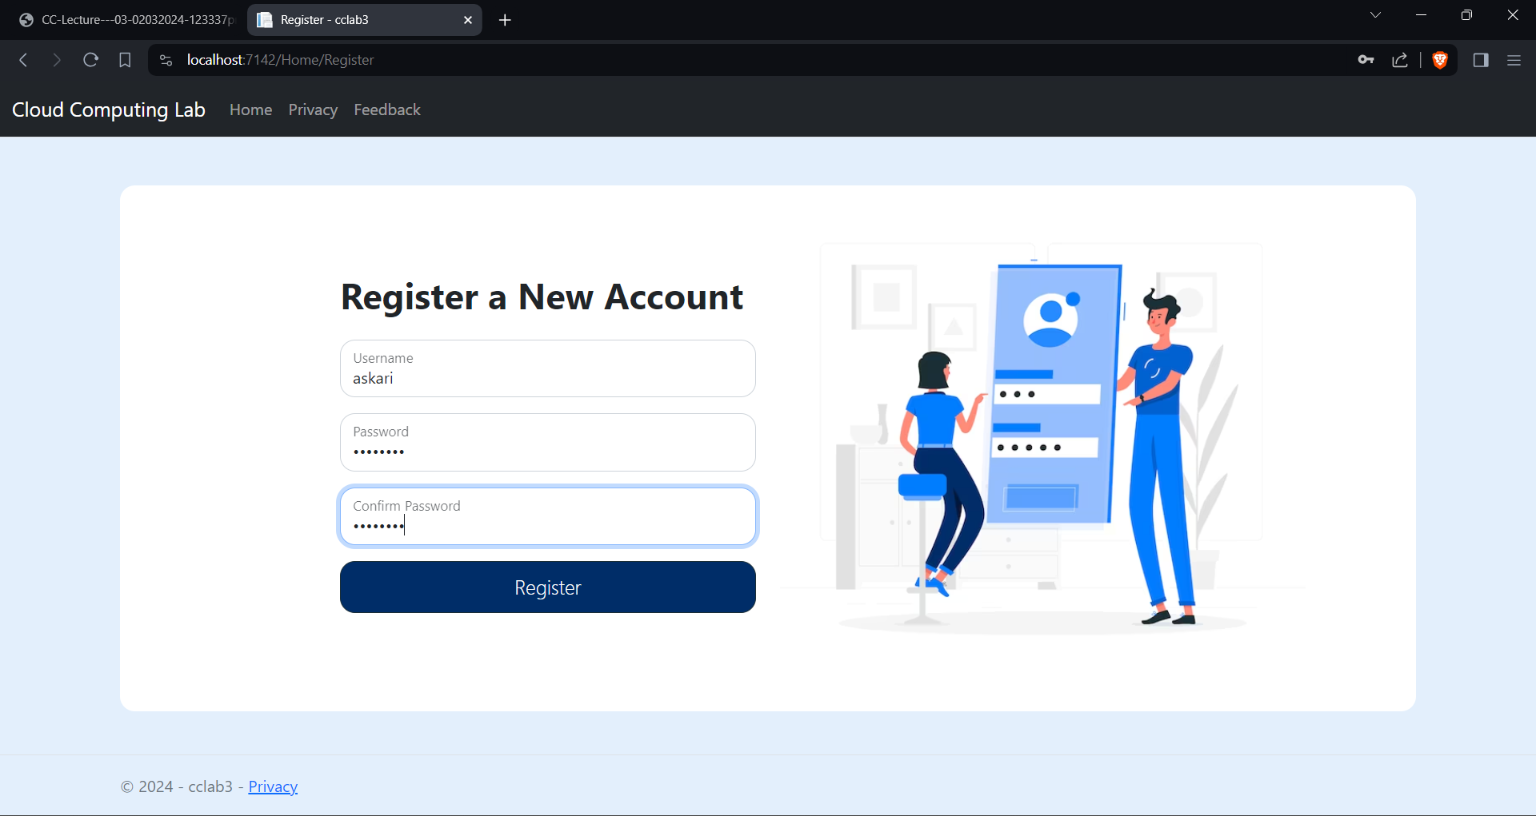

**Home Controller**

using cclab3.Models.LoginViewModel;

using Microsoft.AspNetCore.Mvc;

using System.Diagnostics;

namespace cclab3.Controllers

{

public class HomeController : Controller

{

private static List<RegisterViewModel> registeredUsers = new List<RegisterViewModel>();

public IActionResult Index()

{

return View();

}

[HttpPost]

public IActionResult Login(RegisterViewModel model)

{

if (model.Username == "zain" && model.Password == "1234")

{

// Successful login

return RedirectToAction("Welcome", new { username = model.Username });

}

else if (UserExists(model.Username,model.Password))

{

return RedirectToAction("Welcome", new { username = model.Username });

}

// Failed login

ViewBag.ErrorMessage = "Invalid username or password";

return View("Index");

}

public IActionResult Welcome(string username)

{

ViewBag.Username = username;

return View("Welcome");

}

public IActionResult Register(RegisterViewModel model)

{

if (ModelState.IsValid)

{

if (model.Password == model.ConfirmPassword)

{

// Check if the username is not already registered

if (!UserExists(model.Username, model.Password))

{

// Register the user

registeredUsers.Add(model);

return RedirectToAction("Index");

}

else

{

ViewBag.ErrorMessage = "Username already exists. Please choose a different username.";

}

}

else

{

ViewBag.ErrorMessage = "Passwords do not match.";

}

}

// If there are validation errors or the registration failed, return to the registration page

return View("Register");

}

public IActionResult Feedback()

{

return View();

}

private bool UserExists(string username, string password)

{

return registeredUsers.Exists(user => user.Username == username && user.Password == password);

}

}

}

**Login Model**

namespace cclab3.Models.LoginViewModel

{

public class LoginPage

{

public string Username { get; set; }

public string Password { get; set; }

}

}

**Register Model**

namespace cclab3.Models.LoginViewModel

{

public class RegisterViewModel : LoginPage

{

public string ConfirmPassword { get; set; }

}

}

**Task 2**

Create feedback form using simple MVC net core**.**

**Feedback View**

@model cclab3.Models.FeedbackViewModel.FeedbackModel

@{

ViewData["Title"] = "Feedback";

}

<**form** **asp-action**="Feedback" method="post" onsubmit="return validateForm()">

<div class="container1">

<div class="row">

<div class="col-md-4 col-lg-2 col-xl-4">

<img src="https://img.freepik.com/free-vector/feedback-loop-concept-illustration_114360-21826.jpg"

class="img-fluid" alt="Feedback image">

</div>

<div class="col-md-8 col-lg-10 col-xl-8">

<h1>Feedback Form</h1>

<**label** **asp-for**="Name">Your Name:</**label**>

<**input** **asp-for**="Name" id="Name" **name**="Name" required>

<**label** **asp-for**="Email">Your Email:</**label**>

<**input** **asp-for**="Email" id="Email" **name**="Email" required>

<**label** **asp-for**="Feedback">Your Feedback:</**label**>

<**textarea** **asp-for**="Feedback" id="Feedback" **name**="Feedback" rows="4" required></**textarea**>

<div class="radio-group">

<label>How likely are you to recommend our website to others?</label>

<div class="form-check form-check-inline">

<**input** class="form-check-input" **type**="radio" **asp-for**="Recommendation" **value**="5">

<label class="form-check-label">Very Likely</label>

</div>

<div class="form-check form-check-inline">

<**input** class="form-check-input" **type**="radio" **asp-for**="Recommendation" **value**="4">

<label class="form-check-label">Likely</label>

</div>

<div class="form-check form-check-inline">

<**input** class="form-check-input" **type**="radio" **asp-for**="Recommendation" **value**="3">

<label class="form-check-label">Neutral</label>

</div>

<div class="form-check form-check-inline">

<**input** class="form-check-input" **type**="radio" **asp-for**="Recommendation" **value**="2">

<label class="form-check-label">Unlikely</label>

</div>

<div class="form-check form-check-inline">

<**input** class="form-check-input" **type**="radio" **asp-for**="Recommendation" **value**="1">

<label class="form-check-label">Very Unlikely</label>

</div>

</div>

<div class="rating-group">

<label>Rate your overall satisfaction:</label>

<div class="form-check form-check-inline">

<**input** class="form-check-input" **type**="radio" **asp-for**="Satisfaction" **value**="5">

<label class="form-check-label">★★★★★</label>

</div>

<div class="form-check form-check-inline">

<**input** class="form-check-input" **type**="radio" **asp-for**="Satisfaction" **value**="4">

<label class="form-check-label">★★★★</label>

</div>

<div class="form-check form-check-inline">

<**input** class="form-check-input" **type**="radio" **asp-for**="Satisfaction" **value**="3">

<label class="form-check-label">★★★</label>

</div>

<div class="form-check form-check-inline">

<**input** class="form-check-input" **type**="radio" **asp-for**="Satisfaction" **value**="2">

<label class="form-check-label">★★</label>

</div>

<div class="form-check form-check-inline">

<**input** class="form-check-input" **type**="radio" **asp-for**="Satisfaction" **value**="1">

<label class="form-check-label">★</label>

</div>

</div>

<button type="submit" class="btn btn-primary btn-lg btn-block reg">Submit Feedback</button>

<div class="error-message" id="error-message"></div>

</div>

</div>

</div>

</**form**>

<style>

.container1 {

box-shadow: 0 0 10px rgba(0, 0, 0, 0.1);

padding: 20px;

width: 100%; /* Adjusted width */

max-width: 100%;

text-align: left;

margin-top: 0rem;

background-color: white;

border-radius: 15px;

display: flex;

flex-direction: column;

margin-bottom: 1rem;

}

h1 {

color: #333;

}

form {

display: flex;

flex-direction: column;

align-items: left;

}

label {

margin-top: 10px;

font-weight: bold;

display: block;

}

input,

textarea {

margin-top: 5px;

padding: 10px;

border: 1px solid #ddd;

border-radius: 8px;

width: 100%;

box-sizing: border-box;

margin-bottom: 10px;

}

.radio-group,

.rating-group {

margin-bottom: 7px;

}

.form-check-inline {

display: inline-block;

margin-right: 15px;

}

.error-message {

color: #ff0000;

margin-bottom: 10px;

}

img {

max-width: 100%;

height: 80%;

width:80%

}

</style>

<script>

function validateForm() {

var name = document.getElementById('Name').value;

var email = document.getElementById('Email').value;

var feedback = document.getElementById('Feedback').value;

var errorMessage = document.getElementById('error-message');

if (name.trim() === '' || email.trim() === '' || feedback.trim() === '') {

errorMessage.innerHTML = 'All fields are required';

return false;

}

errorMessage.innerHTML = ''; // Clear any previous error message

return true;

}

</script>

**Feedback Model**

namespace cclab3.Models.FeedbackViewModel

{

public class FeedbackModel

{

public string Name { get; set; }

public string Email { get; set; }

public string Feedback { get; set; }

public int Recommendation { get; set; }

public int Satisfaction { get; set; }

}

}

**Feedback Controller**

Same controller as in the previous task. Feedback action is implemented there.

